Aphrodite
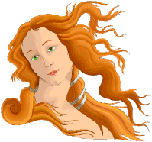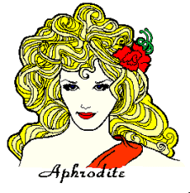
APHRODITE
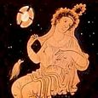
APHRODITE
Modern Spellings: Aphrodite (En, Fr), Afrodita (Es), Afrodite (It)
Roman Name: Venus
Goddess of: Love, Beauty, Pleasure, Procreation
Parents: God Zeus & Titanis Dione; or Born of the Sea-Foam
Spouse: Hephaistos, perhaps later Ares
Offspring: Eros, others see pg 10 (below)
Animals: Turtle dove, Sparrow, Goose, Hare
Plants: Apple Tree, Rose, Myrtle, Myrrh Tree, Anemone, Lettuce
Iconography: Eros (winged godling), Apple, Dove

Zeus

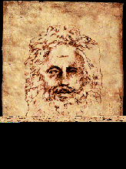
ZEUS
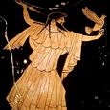
ZEUS
Modern Spellings: Zeus (En, Fr, Es, It)
Roman Name: Jupiter, Jove
God of: King of Heaven, Sky, Weather, Fate, Kingship
Parents: Titan Kronos & Titanis Rhea
Spouse: Hera
Offspring: Athene, Apollon, Artemis, Ares, Aphrodite, Hermes, Dionysos, Herakles, others see pg 2 (below)
Animals: Golden eagle, Wolf
Plants: Oak, Celery
Iconography: Lightning bolt, Lotus staff, Eagle, Oak wreath

Poseidon
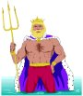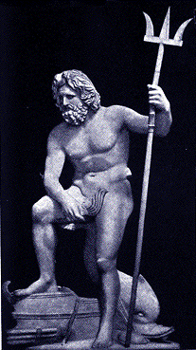
POSEIDON
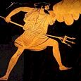
POSEIDON
Modern Spell.: Poseidon (En), Poséidon (Fr), Poseidón (Es), Poseidone (It)
Roman Name: Neptunus (Neptune)
God of: King of the Seas, Rivers, Earthquakes, Horses
Parents: Titan Kronos & Titanis Rhea
Spouse: Amphitrite
Offspring: Triton, others see pg 2 (below)
Animals: Horse, Bull, Dolphin
Plants: Seaweed, Pine Tree
Iconography: Trident, Fish

Hades
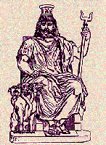
Demeter
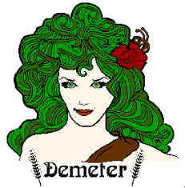
DEMETER
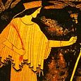
DEMETER
Modern Spellings: Demeter (En), Déméter (Fr), Deméter (Es), Demetra (It)
Roman Name: Ceres
Goddess of: Agriculture, Grain & Bread, The Afterlife
Parents: Titan Kronos & Titanis Rhea
Spouse: None
Offspring: Persephone, Ploutos, others see pg 8 (below)
Animals: Serpent, Swine, Gecko
Plants: Wheat, Barley, Poppy, Mint
Iconography: Grain Sheaf, Lotus Staff, Torch, Cornucopia
Athena
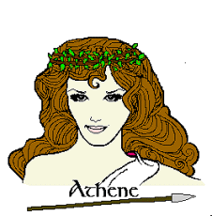
ATHENE
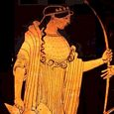
ATHENE
Modern Spellings: Athena (En), Athéna (Fr), Atenea (Es), Atena (It)
Roman Name: Minerva
Goddess of: Warcraft, Heroism, Counsel, Pottery, Weaving, Olives & Oil
Parents: God Zeus & Titanis Metis
Spouse: None (Virgin Goddess)
Offspring: None (Virgin Goddess)
Animals: Little Owl, Crow
Plants: Olive Tree
Iconography: Greek helmet, Aigis (Goat-skin breastplate), Spear

Hestia
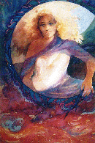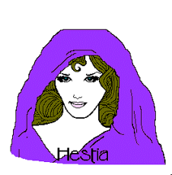

Ares
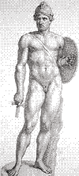
ARES
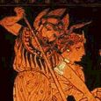
ARES
Modern Spellings: Ares (En, Es, It), Arès (Fr)
Roman Name: Mars
God of: War, Battle, Manliness
Parents: God Zeus & Goddess Hera
Spouse: Perhaps Aphrodite
Offspring: Deimos, Phobos, others see pg 8 (below)
Animals: Serpent, Vulture, Woodpecker, Eagle-owl
Plants: Perhaps Manna Ash
Iconography: Helmet, Spear
Apollo
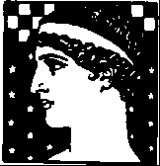
APOLLON
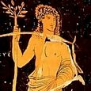
APOLLON
Modern Spellings: Apollo (En, It), Apollon (Fr), Apolo (Es)
Roman Name: Apollo
God of: Music, Prophecy, Education, Healing & Disease
Parents: God Zeus and Titanis Leto
Spouse: None
Offspring: Asklepios, others see pg 2 (below)
Animals: Swan, Raven, Mouse, Wolf
Plants: Laurel, Larkspur
Iconography: Lyre, Laurel wreath or branch, Bow & arrows, Delphic tripod
Hermes
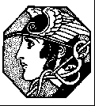
HERMES
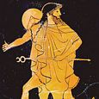
HERMES
Modern Spellings: Hermes (En, Es), Hermès (Fr), Ermes (It)
Roman Name: Mercurius (Mercury)
God of: Animal Husbandry, Travel, Trade, Athletics, Language, Thievery, Good Luck, Guide of the Dead, Herald of the Gods
Parents: God Zeus & Nymphe Maia
Spouse: None
Children: Pan, others see pg 9 (below)
Animals: Tortoise, Sheep, Cattle, Hawk
Plants: Crocus, Strawberry Tree
Iconography: Kerykeion

Artemis
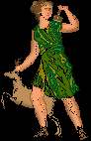
ARTEMIS
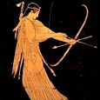
ARTEMIS
Modern Spellings: Artemis (En), Artémis (Fr), Artemisa (Es), Artemide (It)
Roman Name: Diana
Goddess of: Hunting, Wild Animals, Children, Choirs, Disease
Parents: God Zeus & Titanis Leto
Spouse: None (Virgin Goddess)
Children: None (Virgin Goddess)
Animals: Deer, Bear, Wild boar, Guinea fowl, Quail
Plants: Cypress, Walnut, Amaranth-flower
Iconography: Bow & arrows, Hunting spears, Lyre, Deer

Hephaestus
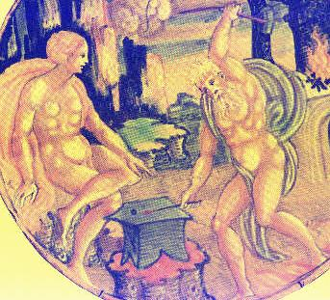
HEPHAISTOS
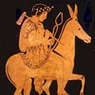
HEPHAISTOS
Modern Spell.: Hephaestus (En), Héphaïstos (Fr), Hefesto (Es), Efesto (It)
Roman Name: Vulcanus (Vulcan)
God of: Metalworking, Fire, Building, Scupture, Volcanism
Parents: Goddess Hera (no father)
Spouse: Aphrodite or Kharis
Offspring: See pg 6 (below)
Animals: Donkey, Crane
Plants: Fennel
Iconography: Hammer, Tongs, Anvil, Donkey, Crane-head

Hera
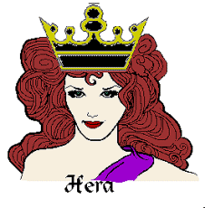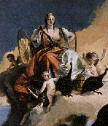
HERA
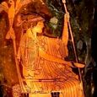
HERA
Modern Spellings: Hera (En, Es), Héra (Fr), Era (It)
Roman Name: Juno
Goddess of: Queen of Heaven, the Sky, Women, Marriage, Impregnation
Parents: Titan Kronos & Titanis Rhea
Spouse: Zeus
Offspring: Ares, Hephaistos, Eileithyia, Hebe, others see pg 2 (below)
Animals: Cuckoo, Peacock, Crane, Hawk, Cow (Heifer), Lion
Plants: Chaste Tree, Pomegranate
Iconography: Lotus staff, Crown, Lion

Dionysus
